Analysis Document on Assignment 04
Tailang (Terry) CAO u1480633
Team member: Yuyao (Spencer) TU
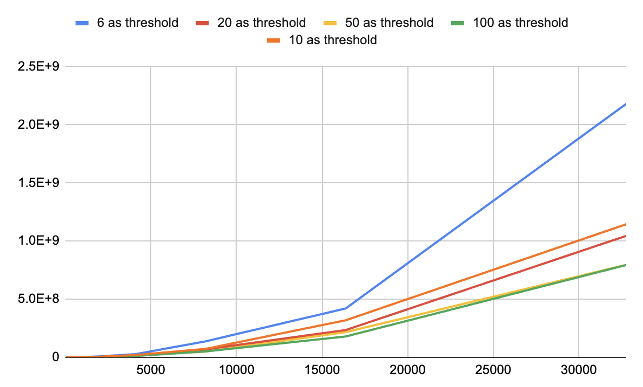
- Mergesort Threshold Experiment

The experiment used 4 different threshold and the result is based on the average taken over 100 iterations and covers size from 2^5 to 2^15. As is shown in the graph, taking 6 as the threshold to switch from insertion sort to merge sort has the worst runtime performance, while taking 50 and 100 as threshold has the similar performance but taking 100 as the threshold is slightly better than 50.

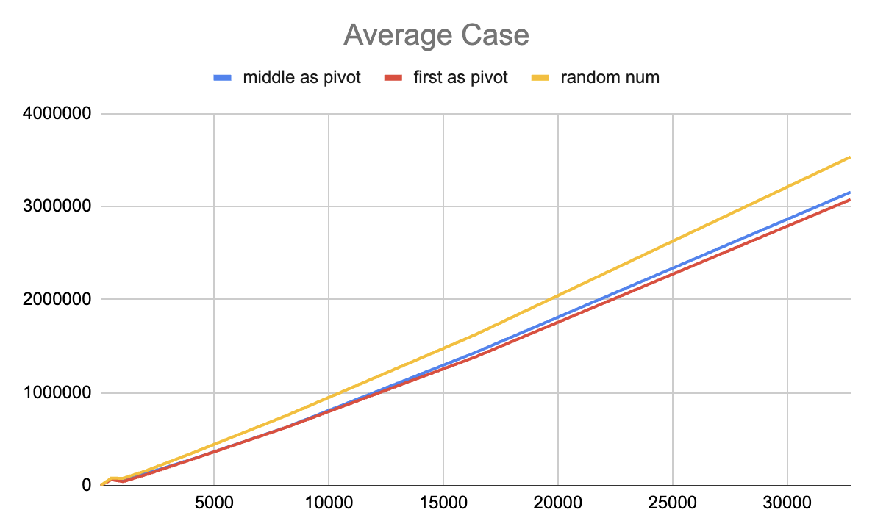
- Quicksort Pivot Experiment

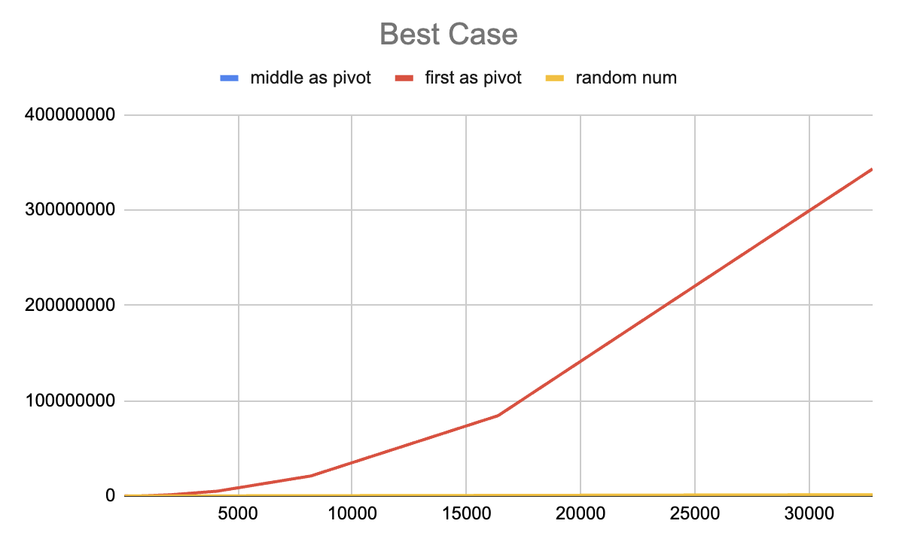

Above is the runtime plot of choosing the first element, the middle element, and a random element as the pivot in the quick sort. (the last element is not considered to be chose as a pivot as it is likely to have the same result of choosing the first element as the pivot). The data is the average result of 100 iterations with the size of the list being from 2^5 to 2^15.
As is shown in the plot, the three methods has similar performance in the case of sorting the average case (a randomly generated arrayList), while taking the first as pivot seems to have a slightly better performance.
However, in the case of best case (an arrayList of integer 1 to required size in ascending order), taking the first element as the pivot has a significantly worse performance comparing with the other 2 pivot choice. This is because in the already sorted list, taking the first element as the pivot means always choosing the smallest number as the pivot, which result in a highly unbalanced partition, and each recursion can only reduce the size of the partition by one element. In the best case scenario, taking the middle element as the pivot has a slightly better performance comparing with taking a random element as the pivot, which is the same in the average case scenario. Therefore, taking the middle element as the pivot is considered to be the best pivot choice and will be implemented in following experiments.
- Mergesort vs. Quicksort Experiment
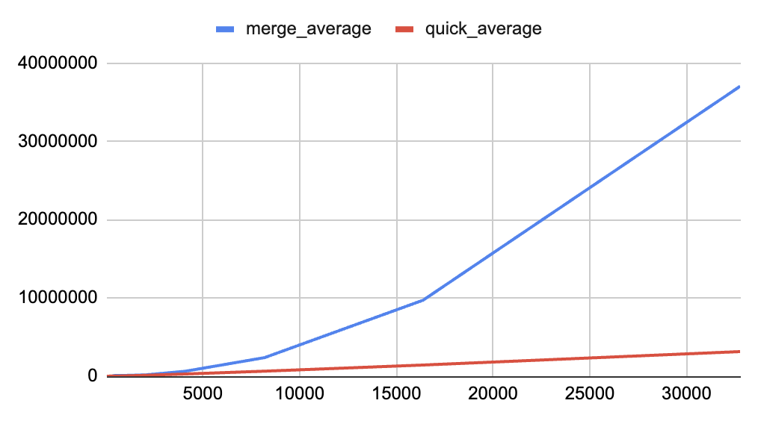

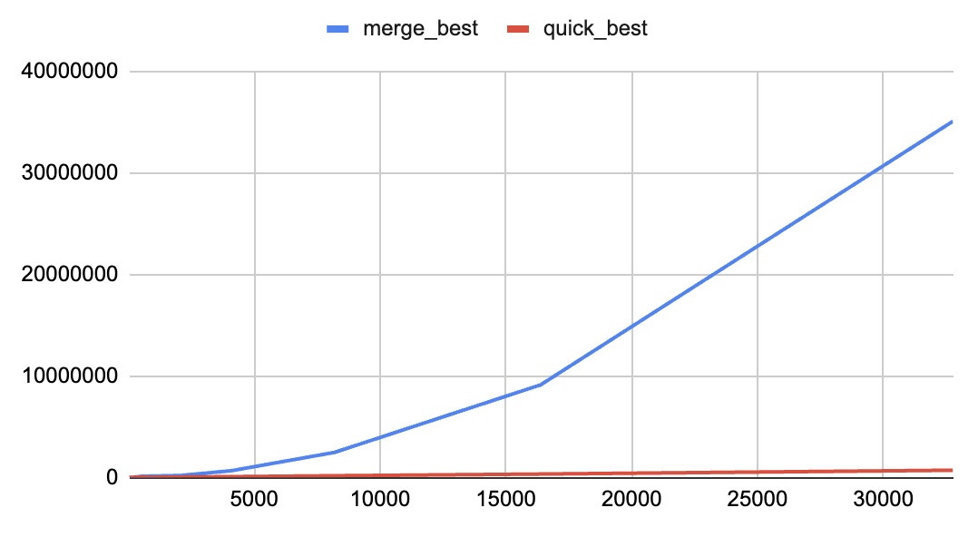

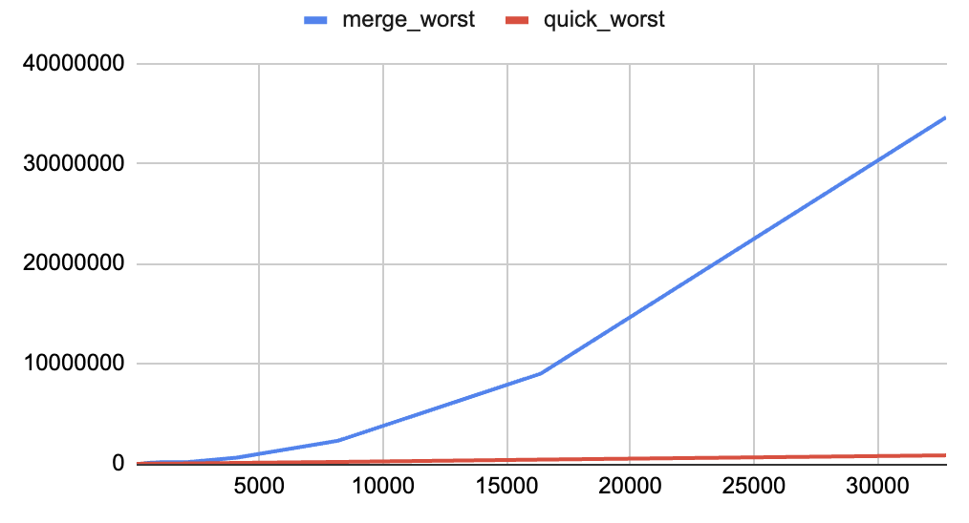

Above is the runtime plots of using merge sort and quick sort with the previously determined best threshold and pivot choice to sort the same array. The data is collected over taking the average of 100 iterations. As is shown in the plots, quick sort has a better performance in all three scenarios comparing with merge sort.
In all three scenios, the runtime performance of

